Page: Eligibility Details

Funding Objective and Scope

Region 10 aims to support WIE Affinity Group to organize various types of activity in their local community. The activity should focus on promoting women in engineering, sciences, and technology in both technical and personal development aspects.

Each year’s theme of activity is different but follows the current mission and vision of IEEE. In 2023-2024, IEEE will pay attention to climate change’s importance and encourage every IEEE organization unit to organize an activity that addresses the need to prevent or stop climate change.

Region 10 WIE also wants to encourage all of our regional AGs to address the needs, challenges, or struggles that WIE has to go through in the era of climate change. IEEE Region 10 WIE committee is then presenting the special support funds for WIE AGs who wish to organize events or activities that would raise the awareness of the World’s Climate Change and the Role of Women in Engineering to combat the challenge or to raise concerns internationally.

Funding eligibility *

Applicants eligibility

Chair of the WIE Affinity Group of each section or Chair of the Student Branch WIE Affinity Group.

- Each WIE Affinity Group can submit one proposal

- All submissions require endorsement from the Section Chair

- Section is encouraged to coordinate with Section WIE AG and Student Branch WIE AGs to comprehensively and strategically propose WIE activities.

Funding Information

- Face-to-Face activities: A maximum of US$ 400

- Hybrid (face-to-face and virtual) activities: A maximum of US$ 400

- Virtual Activities: A maximum of US$ 200

Please itemize all expenses in US dollars only (please do not use local currency in the proposal).
Individual travel expenses (of any kind) will not be approved.

Please check all that applies:
Select one or more options
☐ Hereby, I confirmed that I'm eligible to apply for Region 10 WIE Special Funding Program.

Organization Type *
Select one option
⭘ IEEE Section WIE Affinity Group
⭘ IEEE Student Branch WIE Affinity Group

IEEE Section Size
Select one option
⭘ Small Section = 500 or less members
⭘ Medium Section = 501 - 1,500 members
⭘ Large Section = 1,501 or more members

[Mandatory requirement]
Policy of section matching fund:

When we support an activity in a large section, R10 WIE supports only equal or less than 50% of total expenses. The remaining funds will have to be supported by the section and/or other sources of funding. If it is a medium section, the support is up to 75% and for a small section, it is 100%

Section Incentives scheme:

The section incentives scheme in R10 is designed to support AGs and SBs. These section incentives are funds that were distributed to sections at the end of the year. Collaborations with students and AGs are highly valued. We hope the sections will be willing to support activities conducted by AGs and SBs.

Page: Applicant Details

First Name *

Last Name *

Email Address *

Applicant Position in IEEE WIE AG

WIE AG Name *

Project / Activity Title *

Project Leader *

Director's Email Address *

Project/Activity type *
Select one option
⭘ WIE Track/Forum in a conference or congress
⭘ Local AG activity
⭘ STAR Program/Pre-University
⭘ Professional/Career Development

Please enter your member number

To help you fill out this form, we allow multiple people to work on a single application. If you would like to invite a colleague or multiple colleagues to assist you in completing your application, click the Manage Collaborators button at the top-right of this form. From there, you will be able to add collaborators - All you need is their name and valid e-mail address. Keep in mind that your application can only be submitted by the individual who started this application. You may also revoke a collaborator's access at any time using the same menu.

Page: Proposal Information

Name of the Program/Activity *

Date *

Mode of activity *
Select one option
⭘ Online
⭘ Onsite
⭘ Hybrid

Place
Venue or online platform link

Objective/Overview of the Event: *
Please describe the objective and overview of the activity. Target audiences of the activity or community.

Climate Change Aspects *
Describe how does your information related to the mission of IEEE Climate Change.

Benefits to Members/Community *

Number of Participants expected: *

Page: Budget Detail

Matching Fund Partnerships *
Please describe any other local, IEEE OUs partnerships that will support the activity/programs as a matching fund partner.

Income Budget *
Please provide a breakdown source of funding to support your program.
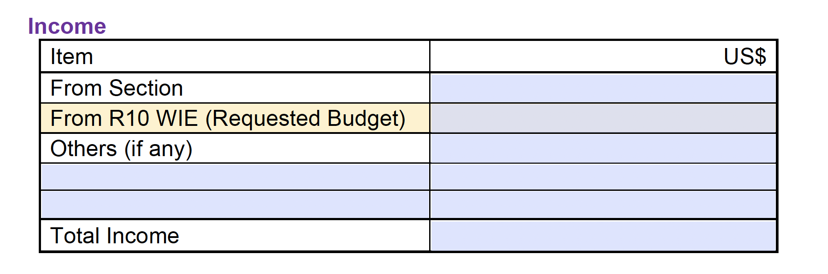

Estimated expense *
Please provide a breakdown of funds to support your program. For example, "50 chairs, $500."
